Exercise: Unit Testing and Modules
Problems for exercises and homework for the "JavaScript Advanced" course @ SoftUni. Upload your solutions here https://softuni.bg/trainings/2840/js-applications-june-2020/internal#lesson-15436.

Unit Testing

Even or Odd
You need to write unit tests for a function isOddOrEven() that checks whether the length of a passed in string is even or odd.
If the passed parameter is NOT a string return undefined. If the parameter is a string return either "even" or "odd" based on the length of the string.

JS Code
You are provided with an implementation of the isOddOrEven() function:
isOddOrEven.js
function isOddOrEven(string) {
if (typeof(string) !== 'string') {
return undefined;
}
if (string.length % 2 === 0) {
return "even";
}
return "odd";
}

Hints
We can clearly see there are three outcomes for the function:
- Returning undefined
- Returning "even"
- Returning "odd"
Write one or two tests passing parameters that are NOT of type string to the function and expecting it to return undefined.
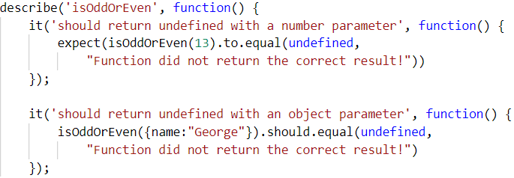

After we have checked the validation it's time to check whether the function works correctly with valid arguments. Write a test for each of the cases:
One where we pass a string with even length:
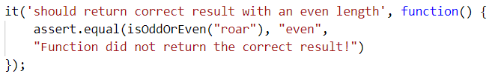
And one where we pass a string with an odd length:
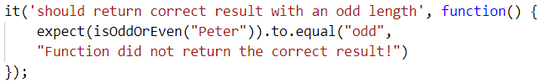
Finally make an extra test passing multiple different strings in a row to ensure the function works correctly:
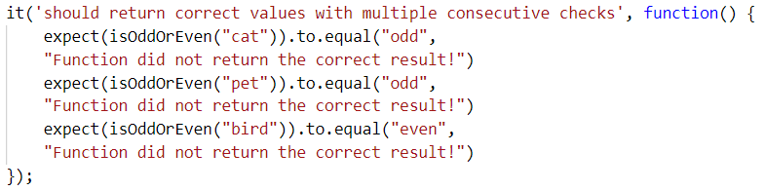

Char Lookup
Write unit tests for a function that retrieves a character at a given index from a passed in string.
You are given a function named lookupChar(), which has the following functionality:
- lookupChar(string, index) - accepts a string and an integer (the index of the char we want to lookup) :
  - If the first parameter is NOT a string or the second parameter is NOT a number - return undefined.
  - If both parameters are of the correct type but the value of the index is incorrect (bigger than or equal to the string length or a negative number) - return "Incorrect index".
  - If both parameters have correct types and values - return the character at the specified index in the string.

JS Code
You are provided with an implementation of the lookupChar() function:
charLookUp.js
function lookupChar(string, index) {
if (typeof(string) !== 'string' || !Number.isInteger(index)) {
return undefined;
}
if (string.length <= index || index < 0) {
return "Incorrect index";
}
return string.charAt(index);
}

Hints
А good first step in testing a method is usually to determine all exit conditions. Reading through the specification or taking a look at the implementation we can easily determine 3 main exit conditions:
- Returning undefined
- Returning an empty string
- Returning the char at the specified index
Now that we have our exit conditions we should start checking in what situations we can reach them. If any of the parameters are of incorrect type, undefined should be returned.
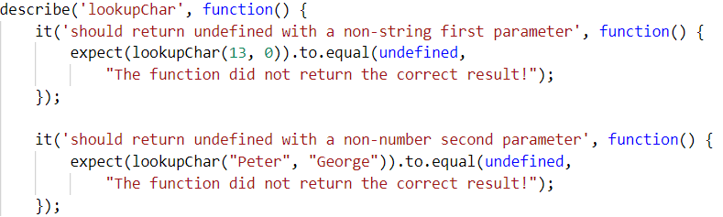
If we take a closer look at the implementation, we see that the check uses Number.isInteger() instead of typeof(index === number) to check the index. While typeof would protect us from getting passed an index that is a non-number, it won’t protect us from being passed a floating-point number. The specification says that index needs to be an integer, since floating point numbers won’t work as indexes.
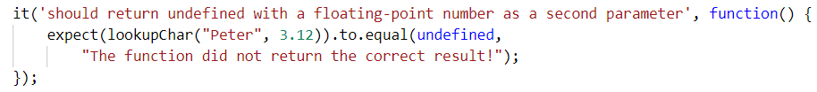
Moving on to the next exit condition - returning an empty string if we get passed an index that is a negative number or an index which is outside of the bounds of the string.
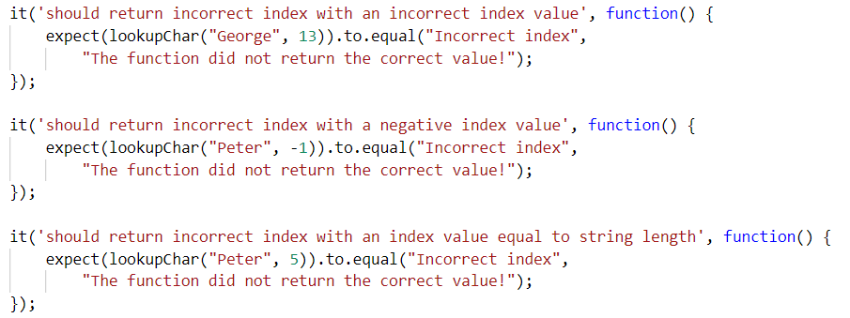
For the last exit condition - returning a correct result. A simple check for the returned value will be enough.
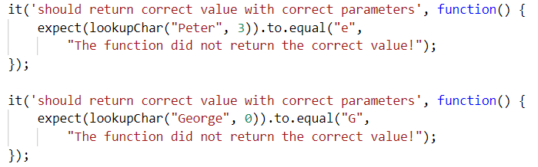
With these last two tests we have covered the lookupChar() function.

Math Enforcer
Your task is to test an object named mathEnforcer, which should have the following functionality:
- addFive(num) - A function that accepts a single parameter:
  - If the parameter is NOT a number, the funtion should return undefined.
  - If the parameter is a number, add 5 to it, and return the result.
- subtractTen(num) - A function that accepts a single parameter:
  - If the parameter is NOT a number, the function should return undefined.
  - If the parameter is a number, subtract 10 from it, and return the result.
- sum(num1, num2) - A function that accepts two parameters:
  - If any of the 2 parameters is NOT a number, the function should return undefined.
  - If both parameters are numbers, the function should return their sum.

JS Code
You are provided with an implementation of the mathEnforcer object:
mathEnforcer.js
let mathEnforcer = {
addFive: function (num) {
if (typeof(num) !== 'number') {
return undefined;
}
return num + 5;
},
subtractTen: function (num) {
if (typeof(num) !== 'number') {
return undefined;
}
return num - 10;
},
sum: function (num1, num2) {
if (typeof(num1) !== 'number' || typeof(num2) !== 'number') {
return undefined;
}
return num1 + num2;
}
};
The methods should function correctly for positive, negative and floating-point numbers. In case of floating-point numbers the result should be considered correct if it is within 0.01 of the correct value.

Screenshots
When testing a more complex object write a nested describe for each function:
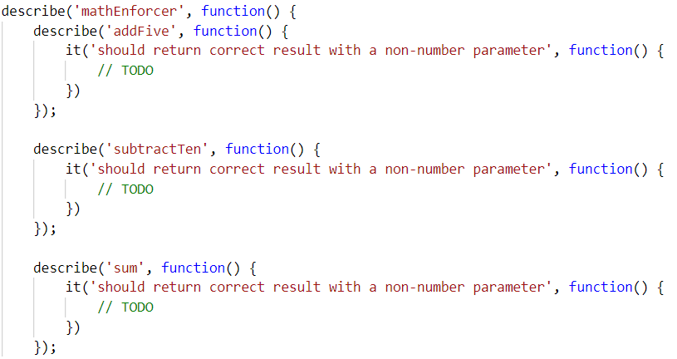
Your tests will be supplied with a variable named "mathEnforcer" which contains the mentioned above logic. All test cases you write should reference this variable.

Hints
- Test how the program behaves when passing in negative values.
- Test the program with floating-point numbers (use Chai’s closeTo() method to compare floating-point numbers).

Unit Testing On Classes

String Builder
You are given the following JavaScript class:
string-builder.js
class StringBuilder {
constructor(string) {
if (string !== undefined) {
StringBuilder._vrfyParam(string);
this._stringArray = Array.from(string);
} else {
this._stringArray = [];
}
}
append(string) {
StringBuilder._vrfyParam(string);
for(let i = 0; i < string.length; i++) {
this._stringArray.push(string[i]);
}
}
prepend(string) {
StringBuilder._vrfyParam(string);
for(let i = string.length - 1; i >= 0; i--) {
this._stringArray.unshift(string[i]);
}
}
insertAt(string, startIndex) {
StringBuilder._vrfyParam(string);
this._stringArray.splice(startIndex, 0, ...string);
}
remove(startIndex, length) {
this._stringArray.splice(startIndex, length);
}
static _vrfyParam(param) {
if (typeof param !== 'string') throw new TypeError('Argument must be string');
}
toString() {
return this._stringArray.join('');
}
}

Functionality
The above code defines a class that holds characters (strings with length 1) in an array. An instance of the class should support the following operations:
- Can be instantiated with a passed in string argument or without anything
- Function append(string) - converts the passed in string argument to an array and adds it to the end of the storage
- Function prepend(string) - converts the passed in string argument to an array and adds it to the beginning of the storage
- Function insertAt(string, index) - converts the passed in string argument to an array and adds it at the given index (there is no need to check if the index is in range)
- Function remove(startIndex, length) - removes elements from the storage, starting at the given index (inclusive), length number of characters (there is no need to check if the index is in range)
- Function toString() - returns a string with all elements joined by an empty string
- All passed in arguments should be strings. If any of them are not, throws a type error with the following message: "Argument must be a string"

Example
This is an example how this code is intended to be used:
Sample code usage |  | Corresponding output
let str = new StringBuilder('hello');  str.append(', there');  str.prepend('User, ');  str.insertAt('woop',5 );  console.log(str.toString());  str.remove(6, 3);  console.log(str.toString()); |  | User,woop hello, there  User,w hello, there

Your Task
Using Mocha and Chai write JS unit tests to test the entire functionality of the StringBuilder class. Make sure it is correctly defined as a class and instances of it have all the required functionality. You may use the following code as a template:
describe("TODO …", function() {
it("TODO …", function() {
// TODO: …
});
// TODO: …
});

Payment Package
You are given the following JavaScript class:
PaymentPackage.js
class PaymentPackage {
constructor(name, value) {
this.name = name;
this.value = value;
this.VAT = 20; // Default value
this.active = true; // Default value
}
get name() {
return this._name;
}
set name(newValue) {
if (typeof newValue !== 'string') {
throw new Error('Name must be a non-empty string');
}
if (newValue.length === 0) {
throw new Error('Name must be a non-empty string');
}
this._name = newValue;
}
get value() {
return this._value;
}
set value(newValue) {
if (typeof newValue !== 'number') {
throw new Error('Value must be a non-negative number');
}
if (newValue < 0) {
throw new Error('Value must be a non-negative number');
}
this._value = newValue;
}
get VAT() {
return this._VAT;
}
set VAT(newValue) {
if (typeof newValue !== 'number') {
throw new Error('VAT must be a non-negative number');
}
if (newValue < 0) {
throw new Error('VAT must be a non-negative number');
}
this._VAT = newValue;
}
get active() {
return this._active;
}
set active(newValue) {
if (typeof newValue !== 'boolean') {
throw new Error('Active status must be a boolean');
}
this._active = newValue;
}
toString() {
const output = [
`Package: ${this.name}` + (this.active === false ? ' (inactive)' : ''),
`- Value (excl. VAT): ${this.value}`,
`- Value (VAT ${this.VAT}%): ${this.value * (1 + this.VAT / 100)}`
];
return output.join('\n');
}
}

Functionality
The above code defines a class that contains information about a payment package. An instance of the class should support the following operations:
- Can be instantiated with two parameters - a string name and number value
- Accessor name - used to get and set the value of name
- Accessor value - used to get and set the value of value
- Accessor VAT - used to get and set the value of VAT
- Accessor active - used to get and set the value of active
- Function toString() - return a string, containing an overview of the instance; if the package is not active, append the label "(inactive)" to the printed name
When creating an instance, or changing any of the property values, the parameters are validated. They must follow these rules:
- name - non-empty string
- value - non-negative number
- VAT - non-negative number
- active - Boolean
If any of the requirements aren’t met, the operation must throw an error.
Scroll down for examples and details about submitting to Judge.

Example
This is an example how this code is intended to be used:
Sample code usage
// Should throw an error
try {
const hrPack = new PaymentPackage('HR Services');
} catch(err) {
console.log('Error: ' + err.message);
}
const packages = [
new PaymentPackage('HR Services', 1500),
new PaymentPackage('Consultation', 800),
new PaymentPackage('Partnership Fee', 7000),
];
console.log(packages.join('\n'));
const wrongPack = new PaymentPackage('Transfer Fee', 100);
// Should throw an error
try {
wrongPack.active = null;
} catch(err) {
console.log('Error: ' + err.message);
}
Corresponding output
Error: Value must be a non-negative number
Package: HR Services
- Value (excl. VAT): 1500
- Value (VAT 20%): 1800
Package: Consultation
- Value (excl. VAT): 800
- Value (VAT 20%): 960
Package: Partnership Fee
- Value (excl. VAT): 7000
- Value (VAT 20%): 8400
Error: Active status must be a boolean

Your Task
Using Mocha and Chai write unit tests to test the entire functionality of the PaymentPackage class. Make sure instances of it have all the required functionality and validation. You may use the following code as a template:
describe("TODO …", function() {
it("TODO …", function() {
// TODO: …
});
// TODO: …
});

7.* Warehouse – Unit Testing
You are given the following JavaScript class:
Warehouse.js
class Warehouse {
get capacity() {
return this._capacity;
}
set capacity(givenSpace) {
if (typeof givenSpace === 'number' && givenSpace > 0) {
return this._capacity = givenSpace;
} else {
throw `Invalid given warehouse space`;
}
}
constructor(capacity) {
this.capacity = capacity;
this.availableProducts = {'Food': {}, 'Drink': {}};
}
addProduct(type, product, quantity) {
let addedQuantity = ((this.capacity - this.occupiedCapacity()) - quantity);
let output;
if (addedQuantity >= 0) {
if (this.availableProducts[type].hasOwnProperty(product) === false) {
this.availableProducts[type][product] = 0;
}
this.availableProducts[type][product] += quantity;
output = this.availableProducts[type];
} else {
throw `There is not enough space or the warehouse is already full`;
}
return output;
}
orderProducts(type) {
let output;
let sortedKeys = Object.keys(this.availableProducts[type])
.sort((a, b) => this.availableProducts[type][b] - this.availableProducts[type][a]);
let newObj = {};
for (let product of sortedKeys) {
if (newObj.hasOwnProperty(product) === false) {
newObj[product] = 0;
}
newObj[product] += this.availableProducts[type][product];
}
this.availableProducts[type] = newObj;
output = this.availableProducts[type];
return output;
}
occupiedCapacity() {
let output = 0;
let productsCount = Object.keys(this.availableProducts['Food']).length +
Object.keys(this.availableProducts['Drink']).length;
if (productsCount > 0) {
let quantityInStock = 0;
for (let type of Object.keys(this.availableProducts)) {
for (let product of Object.keys(this.availableProducts[type])) {
quantityInStock += this.availableProducts[type][product];
}
}
output = quantityInStock;
}
return output;
}
revision() {
let output = "";
if (this.occupiedCapacity() > 0) {
for (let type of Object.keys(this.availableProducts)) {
output += `Product type - [${type}]\n`;
for (let product of Object.keys(this.availableProducts[type])) {
output += `- ${product} ${this.availableProducts[type][product]}\n`;
}
}
} else {
output = 'The warehouse is empty';
}
return output.trim();
}
scrapeAProduct(product, quantity) {
let type = Object.keys(this.availableProducts).find(t => Object.keys(this.availableProducts[t]).includes(product));
let output;
if (type !== undefined) {
if (quantity <= this.availableProducts[type][product]) {
this.availableProducts[type][product] -= quantity;
} else {
this.availableProducts[type][product] = 0;
}
output = this.availableProducts[type];
} else {
throw `${product} do not exists`;
}
return output;
}
}

Functionality
An instance of the Vacation class should support the following operations:
If the constructor gets a negative number or 0 should throw a string:
"Invalid given warehouse space"
AddProduct(type, Product, Quantity)
Adds the given product if there is space in the warehouse and return the object with the given type with already added products. In these cases when the product is added more than 1 time, the quantity should be sum. When there is no place for the current product, you should throw a string that says:
"There is not enough space or the warehouse is already full"
OrderProducts(type)
Sorts all products of a given type in descending order by the quantity.
OccupiedCapacity()
Returns a number, which represents the already occupied place in the warehouse.
Revision()
Returns a string in which we print all products of each type, into the following format:
'Product type - [Food]'
- {product} {quantity}
- {product} quantity
...
...
'Product type - [Drink]'
- {product} {quantity}
- {product} quantity
...
...
If there is not at least 1 product in the warehouse we return the string:
'The Warehouse is empty'
ScrapeAProduct(product, Quantity)
If the given product exists we reduce his quantity, otherwise we reset it. If we cannot find the given product we return the string:
'{product} do not exists'

TODO
Using Mocha and Chai write JS unit tests to test the entire functionality of the Vacation class. You may use the following code as a template:
Submit only your describe() statements..
describe("TODO …", function() {
it("TODO …", function() {
// TODO: …
});
// TODO: …
});

describe("TODO …", function() {
it("TODO …", function() {
// TODO: …
});
// TODO: …
});
...
...
Don't forget to require the chai library!

*C# Console
Write Mocha Unit tests to verify the functionality of a JavaScript implementation of the C# Console class. If you've written some code in C#, you would know that you can format text using placeholders, an example would look like this:
Console.WriteLine("The sum of {0} and {1} is {2}", 3, 4, 7);
Here the first placeholder {0} is exchanged for the first parameter passed after the text template - 3. The second placeholder {1} for the second parameter - 4 and so on.
You will be provied with a class Console which has similar functionality to the C# one. The Console should have a static method writeLine which supports the following:
- writeLine(string) - if only a single argument is passed and it is a string, the function should simply return it.
- writeLine(object) - if only a single parameter is passed and it is an object - return the JSON representation of the object.
- writeLine(templateString, parameters) - It should support the following:
  - If multiple arguments are passed, but the first is not a string - throw a TypeError.
  - If the number of parameters does not correspond to the number of placeholders in the template string - throw a RangeError.
  - If the placeholders have indexes not withing the parameters range(for instance we have a placeholder {13} and only 5 params) throw a RangeError.
  - If multiple arguments are passed and the first is a string, find all placeholders from the string and exchange them with the supplied parameters.
Any cases not mentioned above, do not need to be checked.

Constraints
- All arguments in the writeLine(templateString, parameters) will be strings.
- There will never be two placeholders with the same number.

JS Code
To ease you in the process, you are provided with an implementation which meets all of the specification requirements for the Console object:
specialConsole.js
class Console {
static get placeholder() {
return /{\d+}/g;
}
static writeLine() {
let message = arguments[0];
if (arguments.length === 1) {
if (typeof (message) === 'object') {
message = JSON.stringify(message);
return message;
}
else if (typeof(message) === 'string') {
return message;
}
}
else {
if (typeof (message) !== 'string') {
throw new TypeError("No string format given!");
}
else {
let tokens = message.match(this.placeholder).sort(function (a, b) {
a = Number(a.substring(1, a.length - 1));
b = Number(b.substring(1, b.length - 1));
return a - b;
});
if (tokens.length !== (arguments.length - 1)) {
throw new RangeError("Incorrect amount of parameters given!");
}
else {
for (let i = 0; i < tokens.length; i++) {
let number = Number(tokens[i].substring(1, tokens[i].length - 1));
if (number !== i) {
throw new RangeError("Incorrect placeholders given!");
}
else {
message = message.replace(tokens[i], arguments[i + 1])
}
}
return message;
}
}
}
}
};
Your tests will be supplied a class named "Console" which contains the above-mentioned logic, all test cases you write should reference this variable. Submit in the Judge your code containing Mocha tests testing the above functionality.

